**Trinity**

**Talks**

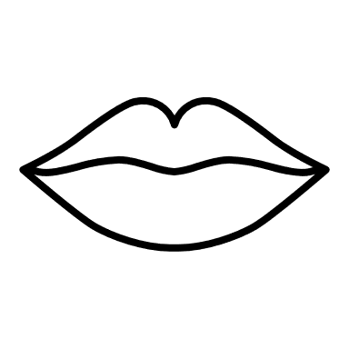

TT



Sign in

**Talks**

**> Reviews**

**> Talks**

**> Gossip**

**> Botd**

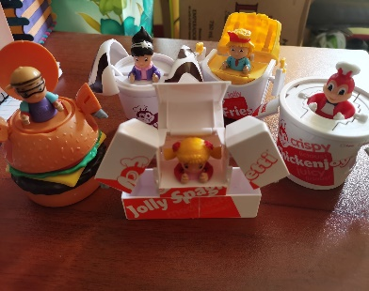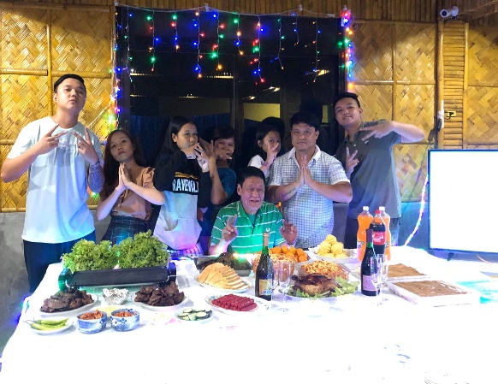

***Final Defense things***

~~~~~~~ ~~~~~~~~~ ~~~~~~~~~ ~~~~~~~

`` ~~~~~~~~~~~~~~~~~~~~~~~~~ ~~~~ ~~~~~~

~ ~~~~~ ~~~~~ ~~~~~~~~~~~~ ~~~~ ~~~~~~~.

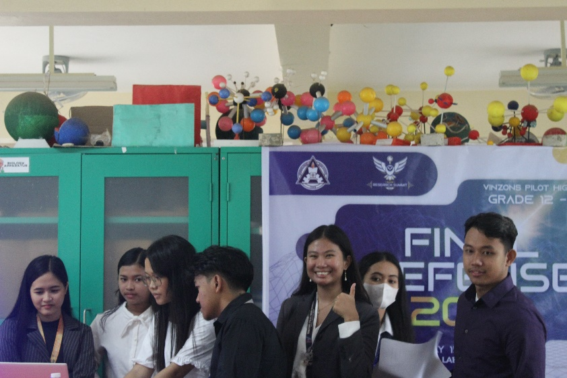

A blogsite of all my review, talks, travels, gossip, and many more

Check out the latest entry! Final Defense things



About the author

Trinity

**Trinity Talks**